Nihal K
Hexaware technologies ltd
Alarms & Ticket Handling Procedure

Table of Contents
OVERVIEW: 2
ALARM MONITORING: 2
TIGOID: 2
TIGO –PROD ALARMS: 2
KINESIS/EVENT PROCESSOR QUEUE: 5
API GATEWAY ALARMS 6
External Kannel API Alarms 7
SECURITY ALARMS 8
RDS-HIGH-CPU ALARM: 9
PAYMENT GATEWAY: 10
PAYMENT GATEWAY PROD ALARMS: 10
API GATEWAY ALARMS 16
EVENT MESSAGE PROCESSOR AND AFS ALARMS 17
PROCEDURE FOR TRACKING THE ALARM: 18
STEPS TO MONITOR THE JIRA TICKETS: 18
SEVERITY FOR ALARM AND JIRA TICKETS: 19
ESCALATION MATRIX 20

PROJECT TITLE: MILLICOM ALARM/TICKET MONITORING

OVERVIEW:
This is a reference document that deals with the monitoring of alarms/tickets. This document provides step-by-step instructions on how to view the alarm, check the alarm, and track the alarm in the Excel sheet.

ALARM MONITORING:
To monitor the alarm, we should concentrate on the following two AWS Prod accounts,
- Tigoid/ DAR (Digital Account Record)
- Payment gateway

TIGOID:
If any alarm is raised from TigoID we are instructed to intimate to the Hexaware-Millicom Team. Give more attention to the PROD alarms and the Alarms that are mentioned below.

TIGO –PROD ALARMS:
The TIGO PROD ALARM is categorized into the following types,
- Timeout alarms
- Lambda Error or Throttle alarms
- Kinesis or Event Processor Queue Alarms
- API Gateway Alarms
- External Kannel API Alarms
- Security Alarms
- RDS Alarms

TIMEOUT ALARMS:

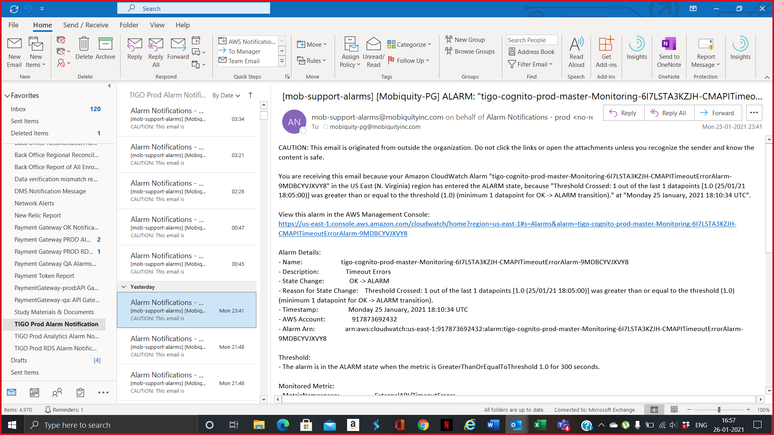
- If any alarms are getting populated in their respective inbox, the NOC (Network Operations Center) Team should verify the “List of Alarms with Action Item” excel sheet and inform the On-Call Team members (on weekends).
Sample CloudWatch Alarms:
- Amazon CloudWatch Alarm "tigo-cognito-prod-master-Monitoring-6I7LSTA3KZJH-CMAPITimeoutErrorAlarm-9MDBCYVJXVY8" in the US East (N. Virginia) region has entered the ALARM state, because "Threshold Crossed: 1 out of the last 1 datapoints [18.0 (04/06/25 14:01:00)] was greater than or equal to the threshold (10.0) (minimum 1 datapoint for OK -> ALARM transition)." at "Wednesday 04 June, 2025 14:06:51 UTC".
- Amazon CloudWatch Alarm "tigo-cognito-prod-master-Monitoring-6I7LSTA3KZJH-DAROTPAPITimeoutAlarm-ZLJXKGI572TM" in the US East (N. Virginia) region has entered the ALARM state, because "Threshold Crossed: 1 out of the last 1 datapoints [21.0 (04/06/25 14:01:00)] was greater than or equal to the threshold (20.0) (minimum 1 datapoint for OK -> ALARM transition)." at "Wednesday 04 June, 2025 14:06:52 UTC".
- Amazon CloudWatch Alarm "tigo-cognito-prod-master-Monitoring-6I7LSTA3KZJH-OrmHETrustedAPITimeoutErrorAlarm-L5HR668RCHRT" in the US East (N. Virginia) region has entered the ALARM state, because "Threshold Crossed: 1 out of the last 1 datapoints [10.0 (25/03/25 09:29:00)] was greater than or equal to the threshold (10.0) (minimum 1 datapoint for OK -> ALARM transition)." at "Tuesday 25 March, 2025 09:34:02 UTC".

LAMBDA ERROR or THROTTLE ALARMS:

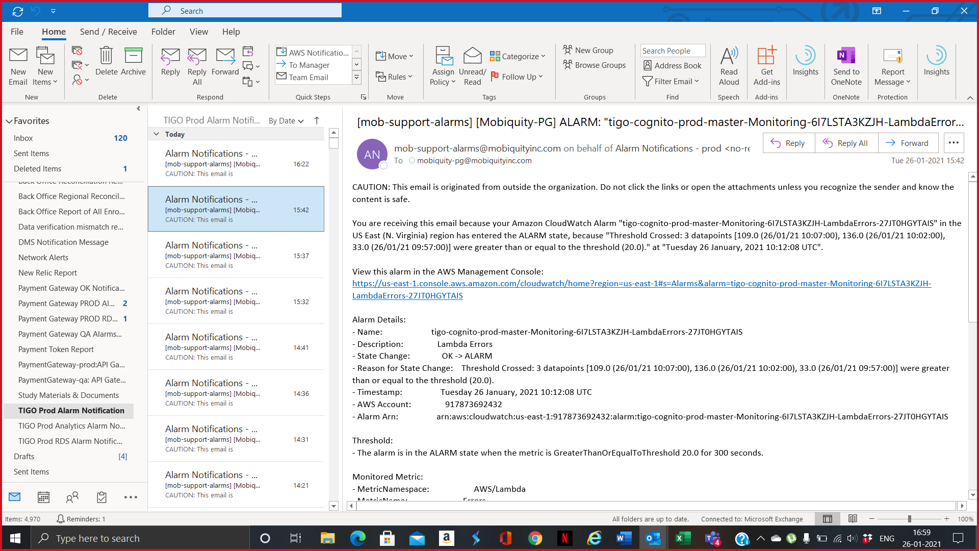
- If any lambda error or throttle alarms are getting populated in their respective inbox, the NOC (Network Operations Center) Team should verify the “List of Alarms with Action Item” excel sheet and inform the On-Call (on weekends) with much more Urgency.

Sample CloudWatch Logs:
- Amazon CloudWatch Alarm "tigo-cognito-prod-master-Monitoring-6I7LSTA3KZJH-LambdaErrors-27JT0HGYTAIS" in the US East (N. Virginia) region has entered the ALARM state, because "Threshold Crossed: 3 out of the last 3 datapoints [54.0 (30/09/25 02:29:00), 54.0 (30/09/25 02:24:00), 79.0 (30/09/25 02:19:00)] were greater than or equal to the threshold (50.0) (minimum 3 datapoints for OK -> ALARM transition)." at "Tuesday 30 September, 2025 02:34:30 UTC".
- Amazon CloudWatch Alarm "tigo-cognito-prod-master-Monitoring-6I7LSTA3KZJH-LambdaThrottles-T4BHZQAJD6PY" in the US East (N. Virginia) region has entered the ALARM state, because "Threshold Crossed: 1 out of the last 1 datapoints [2.0 (29/09/25 22:07:00)] was greater than or equal to the threshold (1.0) (minimum 1 datapoint for OK -> ALARM transition)." at "Monday 29 September, 2025 22:12:41 UTC".

KINESIS/EVENT PROCESSOR QUEUE:

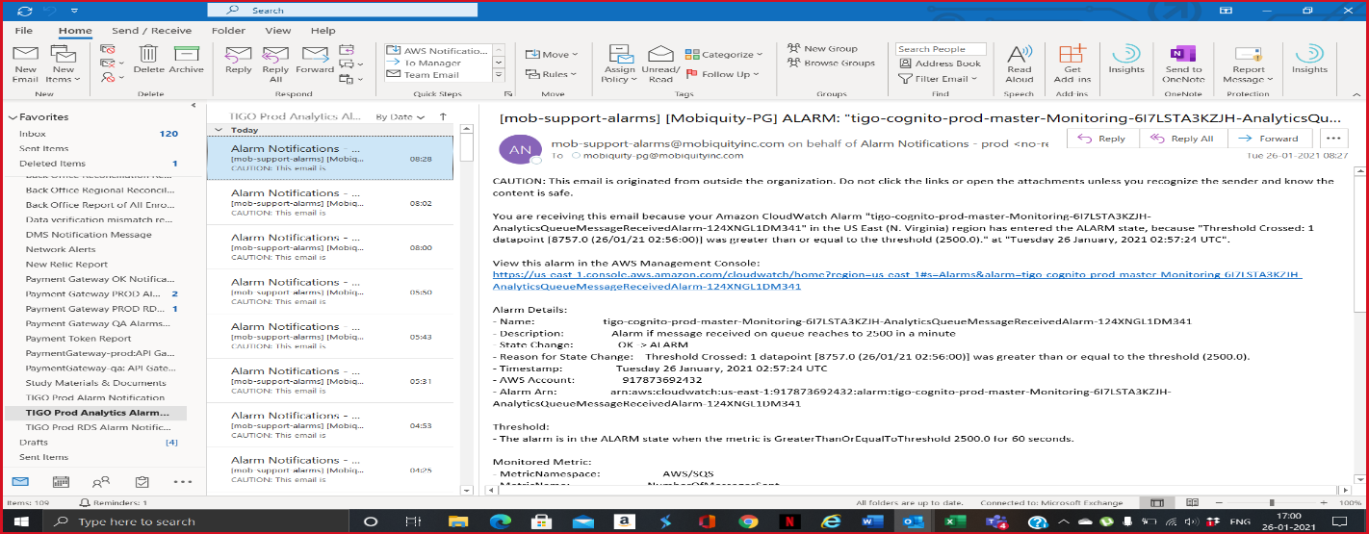
- Kinesis/Event Processor Queue alarms should also be given higher attention and the NOC (Network Operations Center) Team should verify the “List of Alarms with Action Item” excel sheet and inform the On-Call (on weekends).
Sample CloudWatch Alarms:
- Amazon CloudWatch Alarm "tigo-cognito-prod-master-Monitoring-6I7LSTA3KZJH-EventProcessorLambdaErrorAlarm-1IYV7BII0AV78" in the US East (N. Virginia) region has entered the ALARM state, because "Threshold Crossed: 1 out of the last 1 datapoints [2.0 (05/09/25 01:58:00)] was greater than or equal to the threshold (1.0) (minimum 1 datapoint for OK -> ALARM transition)." at "Friday 05 September, 2025 02:08:51 UTC".
- Amazon CloudWatch Alarm "tigo-cognito-prod-master-Monitoring-6I7LSTA3KZJH-KinesisDataStreamAPITimeoutErrorAlarm-SIPBYU2TYMV7" in the US East (N. Virginia) region has entered the ALARM state, because "Threshold Crossed: 1 out of the last 1 datapoints [126.0 (25/09/25 17:21:00)] was greater than or equal to the threshold (40.0) (minimum 1 datapoint for OK -> ALARM transition)." at "Thursday 25 September, 2025 17:36:13 UTC".

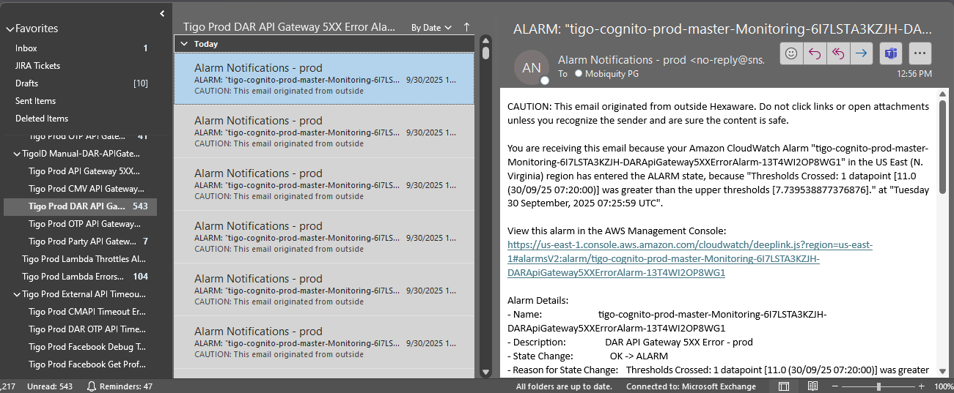
API GATEWAY ALARMS

- API Gateway 4xx or 5xx alarms should be given equal importance and the NOC (Network Operations Center) Team should verify the “List of Alarms with Action Item” excel sheet and inform the On-Call (on weekends). Focus on occurrences and threshold value specifically for these alarms.
Sample CloudWatch Alarms:
- Amazon CloudWatch Alarm "tigo-cognito-prod-master-Monitoring-6I7LSTA3KZJH-DARApiGateway5XXErrorAlarm-13T4WI2OP8WG1" in the US East (N. Virginia) region has entered the ALARM state, because "Thresholds Crossed: 1 datapoint [11.0 (30/09/25 07:20:00)] was greater than the upper thresholds [7.739538877376876]." at "Tuesday 30 September, 2025 07:25:59 UTC".
- Amazon CloudWatch Alarm "tigo-cognito-prod-master-Monitoring-6I7LSTA3KZJH-DARApiGateway4XXErrorAlarm-1RU6CTB3HN9ZJ" in the US East (N. Virginia) region has entered the ALARM state, because "Thresholds Crossed: 1 datapoint [3082.0 (27/09/25 00:30:00)] was greater than the upper thresholds [3001.4837059621204]." at "Saturday 27 September, 2025 00:35:45 UTC".

External Kannel API Alarms
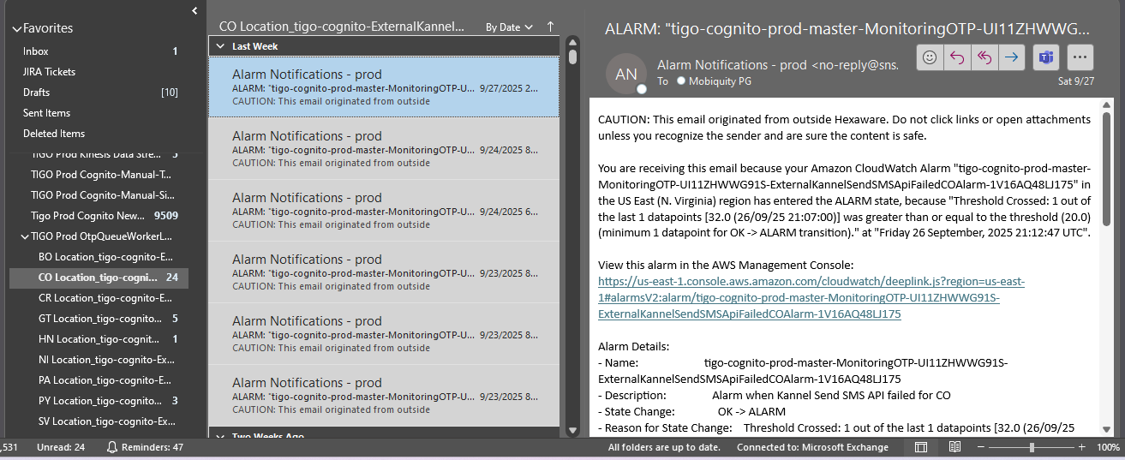

- External Kannel API alarms or OTP Queue Age Of Oldest Message Alarms are the External API’s managed by Millicom. L2 Team would be able to investigate this alarm only when it’s in Alarm State. So, in this case NOC (Network Operations Center) Team should verify the “List of Alarms with Action Item” excel sheet and inform the On-Call (on weekends) within 15 – 25 mins. Focus on occurrences and threshold value specifically for these alarms as well.
Sample CloudWatch Alarms:
- Amazon CloudWatch Alarm "tigo-cognito-prod-master-MonitoringOTP-UI11ZHWWG91S-ExternalKannelSendSMSApiFailedCOAlarm-1V16AQ48LJ175" in the US East (N. Virginia) region has entered the ALARM state, because "Threshold Crossed: 1 out of the last 1 datapoints [32.0 (26/09/25 21:07:00)] was greater than or equal to the threshold (20.0) (minimum 1 datapoint for OK -> ALARM transition)." at "Friday 26 September, 2025 21:12:47 UTC".
- Amazon CloudWatch Alarm "tigo-cognito-prod-master-MonitoringOTP-UI11ZHWWG91S-OtpQueueAgeOfOldestMessageAlarm-48MGX1R6ANYA" in the US East (N. Virginia) region has entered the ALARM state, because "Threshold Crossed: 1 datapoint [15.0 (27/09/25 13:29:00)] was greater than or equal to the threshold (15.0)." at "Saturday 27 September, 2025 13:35:33 UTC".

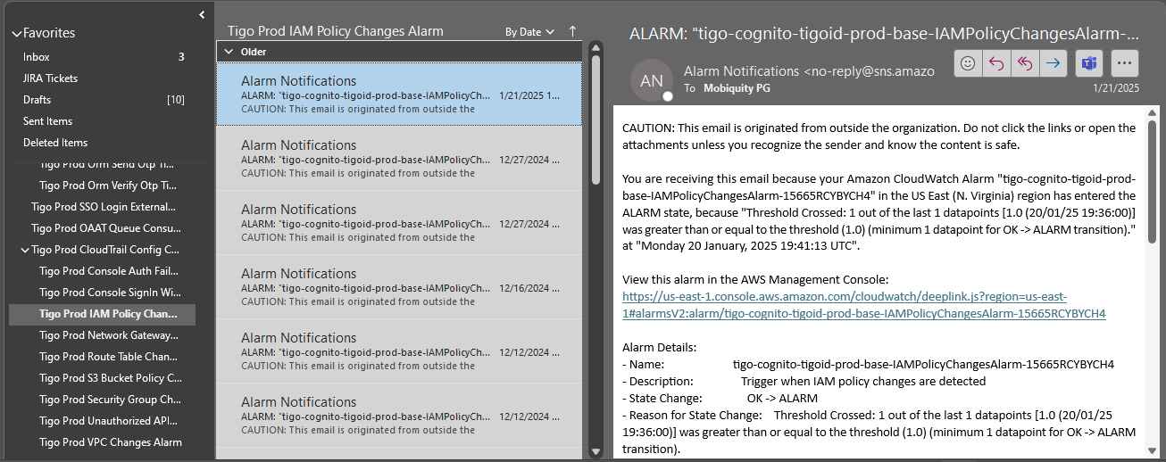
SECURITY ALARMS

- The Security alarm related to any configuration changes like IAM Policy Change, Console SignIn Without MFA, Console Auth Failure, Network Gateway Change, Route Table Changes, S3 Bucket Policy Changes, Security Group Change, VPC Change, Unauthorized API Call and CloudTrail Config changes. So, in this case NOC (Network Operations Center) Team should verify the “List of Alarms with Action Item” excel sheet and inform the On-Call (on weekends) within 15 – 25 mins. If in case of any activity, then these alarms can be ignored else this alarm should be considered as Priority P2.
Sample CloudWatch Alarms:
- Amazon CloudWatch Alarm "tigo-cognito-tigoid-prod-base-CloudTrailConfigChangesAlarm-18IJZIR2UFAUS" in the US East (N. Virginia) region has entered the ALARM state, because "Threshold Crossed: 1 out of the last 1 datapoints [1.0 (21/01/25 17:25:00)] was greater than or equal to the threshold (1.0) (minimum 1 datapoint for OK -> ALARM transition)." at "Tuesday 21 January, 2025 17:30:34 UTC".
- Amazon CloudWatch Alarm "tigo-cognito-tigoid-prod-base-IAMPolicyChangesAlarm-15665RCYBYCH4" in the US East (N. Virginia) region has entered the ALARM state, because "Threshold Crossed: 1 out of the last 1 datapoints [1.0 (20/01/25 19:36:00)] was greater than or equal to the threshold (1.0) (minimum 1 datapoint for OK -> ALARM transition)." at "Monday 20 January, 2025 19:41:13 UTC".
- Amazon CloudWatch Alarm "tigo-cognito-tigoid-prod-base-UnauthorizedAPICallsAlarm-1XGEUVQ5OP4G7" in the US East (N. Virginia) region has entered the ALARM state, because "Threshold Crossed: 1 out of the last 1 datapoints [1.0 (17/01/25 22:38:00)] was greater than or equal to the threshold (1.0) (minimum 1 datapoint for OK -> ALARM transition)." at "Friday 17 January, 2025 22:43:51 UTC".

RDS-HIGH-CPU ALARM:

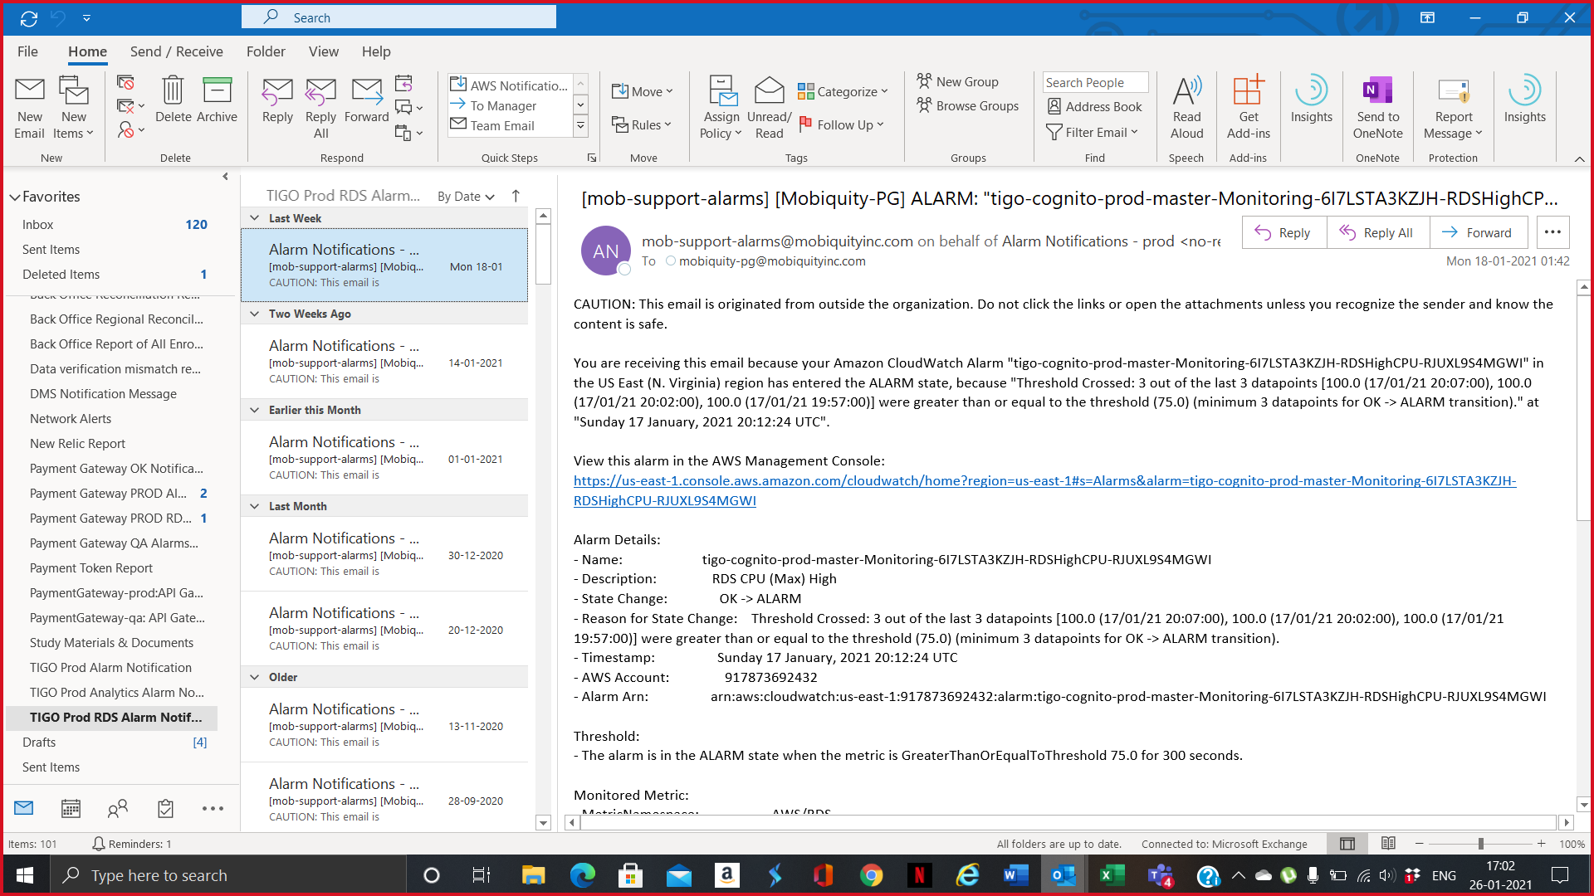

- RDS-HIGH-CPU alarms are to be given utmost importance, and the NOC (Network Operations Center) Team should verify the “List of Alarms with Action Item” excel sheet and inform the On-Call (on weekends) immediately.
Sample CloudWatch Alarms:
- Amazon CloudWatch Alarm "tigo-cognito-prod-master-Monitoring-6I7LSTA3KZJH-RDSHighCPU-RJUXL9S4MGWI" in the US East (N. Virginia) region has entered the ALARM state, because "Threshold Crossed: 3 out of the last 3 datapoints [100.0 (17/01/21 20:07:00), 100.0 (17/01/21 20:02:00), 100.0 (17/01/21 19:57:00)] were greater than or equal to the threshold (75.0) (minimum 3 datapoints for OK -> ALARM transition)." at "Sunday 17 January 2021 20:12:24 UTC".

PAYMENT GATEWAY:
It is a payment process platform, as instructed by the team members we should give more attention to the following alarm,

PAYMENT GATEWAY PROD ALARMS:
The payment gateway prod alarm is classified into the following types,
- Microservice Exceptions Alarm
- Worker and Batch Exceptions Alarm
- Security Alarms
- RDS Alarms
- API Gateway
- Event Message Processor and AFS Alarms

MICROSERVICE EXCEPTIONS ALARM:
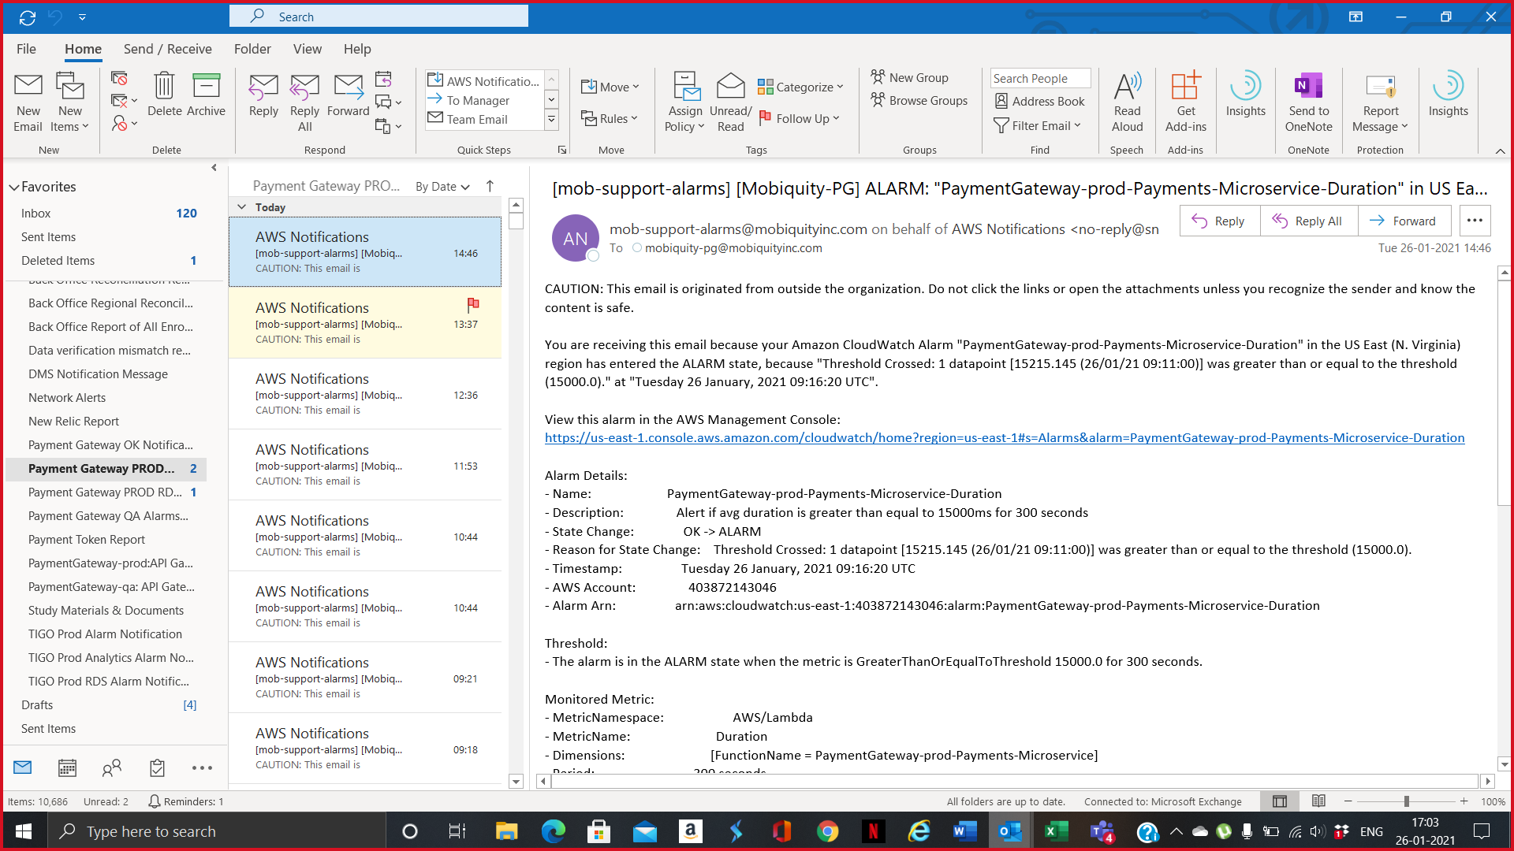
- If any Microservices alarms getting triggered, then the NOC (Network Operations Center) Team should verify the “List of Alarms with Action Item” excel sheet and inform the On-Call (on weekends). These alarms are low priority but still there might be few 5xx issues that can be triggered if in case of a huge spike occurring. So, focus more on occurrence while working on these exceptions.
Sample CloudWatch Alarms:
- Amazon CloudWatch Alarm "PaymentGateway-prod-AsyncPayments-Microservice-Exceptions" in the US East (N. Virginia) region has entered the ALARM state, because "Threshold Crossed: 1 datapoint [10.0 (26/01/21 00:08:00)] was greater than or equal to the threshold (10.0)." at "Tuesday 26 January 2021 00:09:29 UTC".
- Amazon CloudWatch Alarm "PaymentGateway-prod-Payment-Token-Microservice-Exceptions" in the US East (N. Virginia) region has entered the ALARM state, because "Threshold Crossed: 1 datapoint [68.0 (30/09/25 03:41:00)] was greater than or equal to the threshold (50.0)." at "Tuesday 30 September, 2025 03:46:10 UTC".
- Amazon CloudWatch Alarm "PaymentGateway-prod-Enrollment-Microservice-Exceptions" in the US East (N. Virginia) region has entered the ALARM state, because "Threshold Crossed: 1 datapoint [10.0 (30/09/25 04:50:00)] was greater than or equal to the threshold (10.0)." at "Tuesday 30 September, 2025 05:05:30 UTC".

WORKER AND BATCH EXCEPTIOSN ALARM:

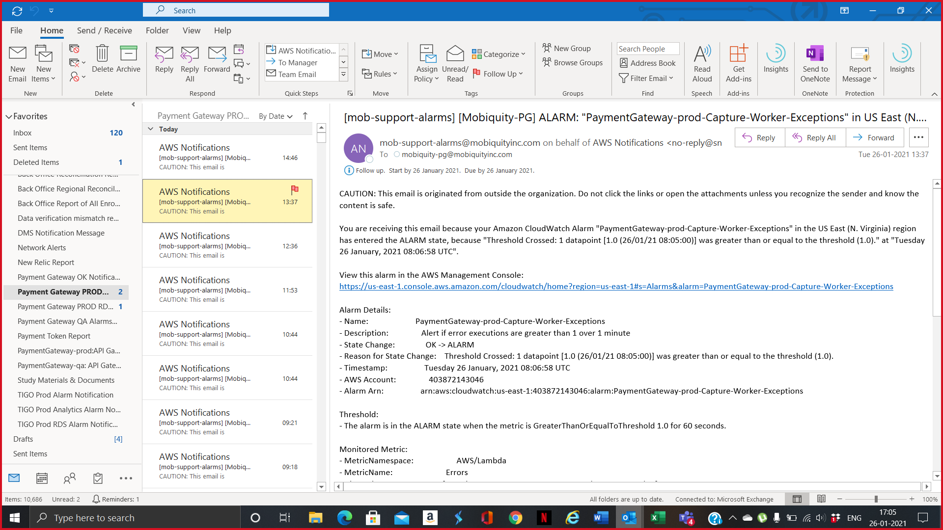
- If the PaymentGateway worker or RP Batch exceptions alarm triggers, the NOC (Network Operations Center) Team should verify the “List of Alarms with Action Item” excel sheet and inform the On-Call (on weekends) with utmost urgency.
Sample CloudWatch Logs:
- Amazon CloudWatch Alarm "PaymentGateway-prod-Capture-Worker-Exceptions" in the US East (N. Virginia) region has entered the ALARM state, because "Threshold Crossed: 1 datapoint [1.0 (26/01/21 08:05:00)] was greater than or equal to the threshold (1.0)." at "Tuesday 26 January 2021 08:06:58 UTC".
- Amazon CloudWatch Alarm "PaymentGateway-prod-FulfillmentCallback-Worker-Exceptions" in the US East (N. Virginia) region has entered the ALARM state, because "Threshold Crossed: 1 out of the last 2 datapoints [1.0 (29/09/25 23:07:00)] was greater than or equal to the threshold (1.0) (minimum 1 datapoint for OK -> ALARM transition)." at "Monday 29 September, 2025 23:12:52 UTC".
- Amazon CloudWatch Alarm "PaymentGateway-prod-RPBatchItemsPayment-Processor-Exceptions" in the US East (N. Virginia) region has entered the ALARM state, because "Threshold Crossed: 1 out of the last 2 datapoints [1.0 (28/09/25 16:26:00)] was greater than or equal to the threshold (1.0) (minimum 1 datapoint for OK -> ALARM transition)." at "Sunday 28 September, 2025 16:31:31 UTC".
- Amazon CloudWatch Alarm "PaymentGateway-prod-RP-Scheduler-BatchItem-Processor-Exceptions" in the US East (N. Virginia) region has entered the ALARM state, because "Threshold Crossed: 1 out of the last 2 datapoints [27.0 (29/09/25 10:53:00)] was greater than or equal to the threshold (15.0) (minimum 1 datapoint for OK -> ALARM transition)." at "Monday 29 September, 2025 10:58:07 UTC".

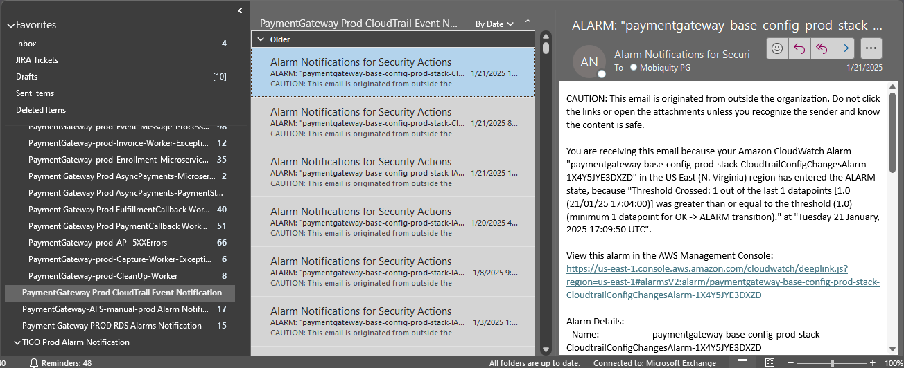
SECURITY ALARMS

- The Security alarm related to any configuration changes like IAM Policy Change, Console SignIn Without MFA, Console Auth Failure, Network Gateway Change, Route Table Changes, S3 Bucket Policy Changes, Security Group Change, VPC Change, Unauthorized API Call and CloudTrail Config changes. So, in this case NOC (Network Operations Center) Team should verify the “List of Alarms with Action Item” excel sheet and inform the On-Call (on weekends) within 15 – 25 mins. If in case of any activity, then these alarms can be ignored else this alarm should be considered as Priority P2.
Sample CloudWatch Alarms:
- Amazon CloudWatch Alarm "paymentgateway-base-config-prod-stack-CloudtrailConfigChangesAlarm-1X4Y5JYE3DXZD" in the US East (N. Virginia) region has entered the ALARM state, because "Threshold Crossed: 1 out of the last 1 datapoints [1.0 (21/01/25 17:04:00)] was greater than or equal to the threshold (1.0) (minimum 1 datapoint for OK -> ALARM transition)." at "Tuesday 21 January, 2025 17:09:50 UTC".
- Amazon CloudWatch Alarm "paymentgateway-base-config-prod-stack-IAMPolicyChangesAlarm-T1PD7XV5K9BQ" in the US East (N. Virginia) region has entered the ALARM state, because "Threshold Crossed: 1 out of the last 1 datapoints [1.0 (20/01/25 19:33:00)] was greater than or equal to the threshold (1.0) (minimum 1 datapoint for OK -> ALARM transition)." at "Monday 20 January, 2025 19:38:06 UTC".
- Amazon CloudWatch Alarm "paymentgateway-base-config-prod-stack-UnauthorizedAPICallsAlarm-1SZOQQ6RN7623" in the US East (N. Virginia) region has entered the ALARM state, because "Threshold Crossed: 1 out of the last 1 datapoints [1.0 (13/11/24 11:30:00)] was greater than or equal to the threshold (1.0) (minimum 1 datapoint for OK -> ALARM transition)." at "Wednesday 13 November, 2024 11:35:11 UTC".

RDS ALARM:

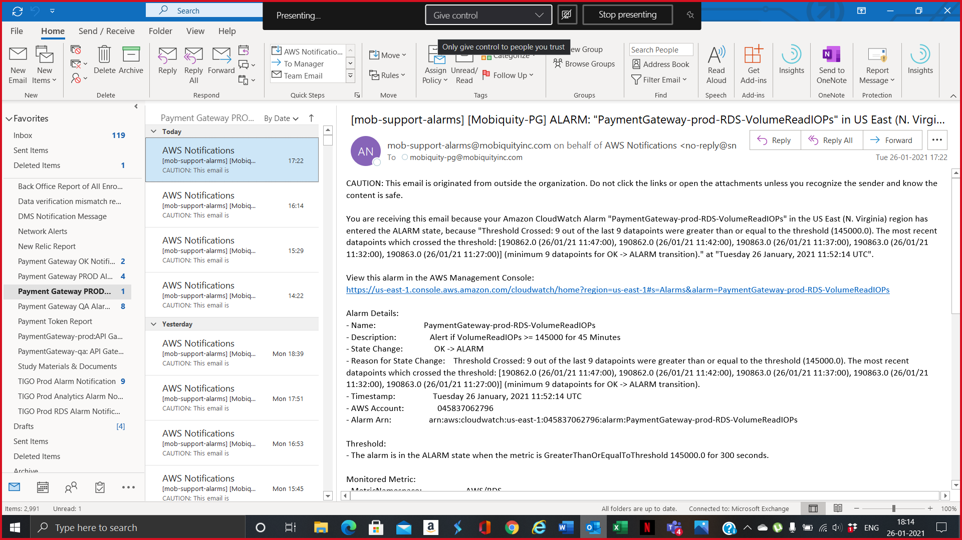
- RDS-HIGH-CPU alarms are to be given utmost importance and the NOC (Network Operations Center) Team should verify the “List of Alarms with Action Item” excel sheet and inform the On-Call (on weekends) immediately. Other RDS Alarms like Volume Read IOPS, Write IOPS, Delete Latency, Update Latency, RDS Queries requires action based on the excel sheet but if RDS HIGH CPU is also getting triggered along with these alarms, please reach On-Call Person within 5-10 minutes.
Sample CloudWatch Alarm:
- Amazon CloudWatch Alarm "PaymentGateway-prod-RDS-VolumeReadIOPs" in the US East (N. Virginia) region has entered the ALARM state, because "Threshold Crossed: 9 out of the last 9 datapoints were greater than or equal to the threshold (130000.0). The most recent datapoints which crossed the threshold: [153334.0 (27/09/25 13:34:00), 153334.0 (27/09/25 13:29:00), 153334.0 (27/09/25 13:24:00), 153334.0 (27/09/25 13:19:00), 158257.0 (27/09/25 13:14:00)] (minimum 9 datapoints for OK -> ALARM transition)." at "Saturday 27 September, 2025 13:39:29 UTC".
- Amazon CloudWatch Alarm "PaymentGateway-prod-RDS-ActiveTransactions" in the US East (N. Virginia) region has entered the ALARM state, because "Threshold Crossed: 5 datapoints were greater than or equal to the threshold (60.0). The most recent datapoints which crossed the threshold: [91.64091827065675 (29/09/25 10:40:00), 118.35962505146149 (29/09/25 10:39:00), 84.86778307416233 (29/09/25 10:38:00), 85.85546075439488 (29/09/25 10:37:00), 105.3226515922961 (29/09/25 10:36:00)]." at "Monday 29 September, 2025 10:41:26 UTC".
- Amazon CloudWatch Alarm "PaymentGateway-prod-RDS-DeleteLatency" in the US East (N. Virginia) region has entered the ALARM state, because "Threshold Crossed: 5 out of the last 5 datapoints were greater than or equal to the threshold (0.5). The most recent datapoints which crossed the threshold: [0.703 (22/09/25 16:51:00), 0.6411428571428572 (22/09/25 16:50:00), 0.6153333333333334 (22/09/25 16:49:00), 0.6468 (22/09/25 16:48:00), 0.7056666666666667 (22/09/25 16:47:00)] (minimum 5 datapoints for OK -> ALARM transition)." at "Monday 22 September, 2025 16:52:33 UTC".
- Amazon CloudWatch Alarm "PaymentGateway-prod-RDS-Queries" in the US East (N. Virginia) region has entered the ALARM state, because "Threshold Crossed: 3 out of the last 3 datapoints [6560.2293180454635 (20/09/25 13:14:00), 6835.683098356831 (20/09/25 13:09:00), 6865.481387676208 (20/09/25 13:04:00)] were greater than or equal to the threshold (6500.0) (minimum 3 datapoints for OK -> ALARM transition)." at "Saturday 20 September, 2025 13:19:30 UTC".
- Amazon CloudWatch Alarm "PaymentGateway-prod-RDS-DatabaseConnections" in the US East (N. Virginia) region has entered the ALARM state, because "Threshold Crossed: 5 datapoints were greater than or equal to the threshold (50.0). The most recent datapoints which crossed the threshold: [54.0 (19/09/25 14:15:00), 50.5 (19/09/25 14:14:00), 52.5 (19/09/25 14:13:00), 55.0 (19/09/25 14:12:00), 50.0 (19/09/25 14:11:00)]." at "Friday 19 September, 2025 14:16:11 UTC".
- Amazon CloudWatch Alarm "PaymentGateway-prod-arc-RDS-cluster-reader-CPUUtilization-Manual" in the US East (N. Virginia) region has entered the ALARM state, because "Threshold Crossed: 3 out of the last 3 datapoints [80.895 (06/06/24 13:18:00), 80.91666666666667 (06/06/24 13:17:00), 64.63333333333334 (06/06/24 13:16:00)] were greater than the threshold (60.0) (minimum 3 datapoints for OK -> ALARM transition)." at "Thursday 06 June, 2024 13:20:41 UTC".
- Amazon CloudWatch Alarm "PaymentGateway-prod-RDS-cluster-reader-CPUUtilization-Manual" in the US East (N. Virginia) region has entered the ALARM state, because "Threshold Crossed: 3 out of the last 3 datapoints [60.14057600857749 (12/07/25 16:09:00), 64.35863391393728 (12/07/25 16:08:00), 70.78951732494156 (12/07/25 16:07:00)] were greater than the threshold (60.0) (minimum 3 datapoints for OK -> ALARM transition)." at "Saturday 12 July, 2025 16:11:26 UTC".

API GATEWAY ALARMS
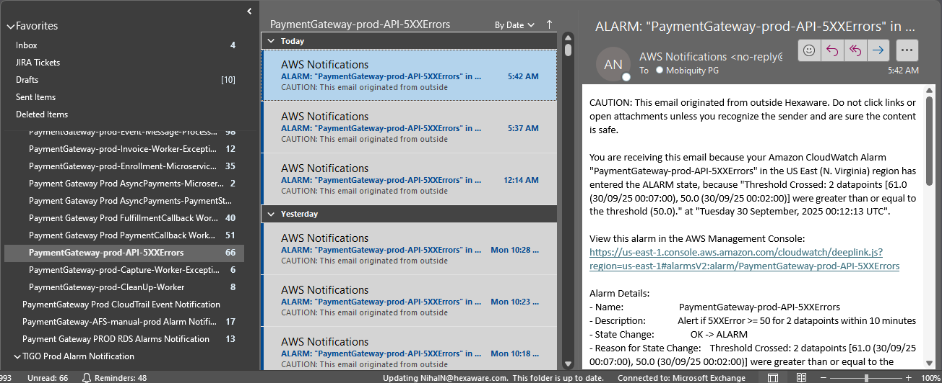

- API Gateway 4xx or 5xx alarms should be given equal importance and the NOC (Network Operations Center) Team should verify the “List of Alarms with Action Item” excel sheet and inform the On-Call (on weekends). Focus on occurrences and threshold value specifically for these alarms.
Sample CloudWatch Alarms:
- Amazon CloudWatch Alarm "PaymentGateway-prod-API-5XXErrors" in the US East (N. Virginia) region has entered the ALARM state, because "Threshold Crossed: 2 datapoints [61.0 (30/09/25 00:07:00), 50.0 (30/09/25 00:02:00)] were greater than or equal to the threshold (50.0)." at "Tuesday 30 September, 2025 00:12:13 UTC".
- Amazon CloudWatch Alarm "PaymentGateway-prod-API-4XXErrors" in the US East (N. Virginia) region has entered the ALARM state, because "Threshold Crossed: 2 datapoints [4978.0 (23/09/25 15:34:00), 2130.0 (23/09/25 15:29:00)] were greater than or equal to the threshold (1800.0)." at "Tuesday 23 September, 2025 15:39:00 UTC".

EVENT MESSAGE PROCESSOR AND AFS ALARMS
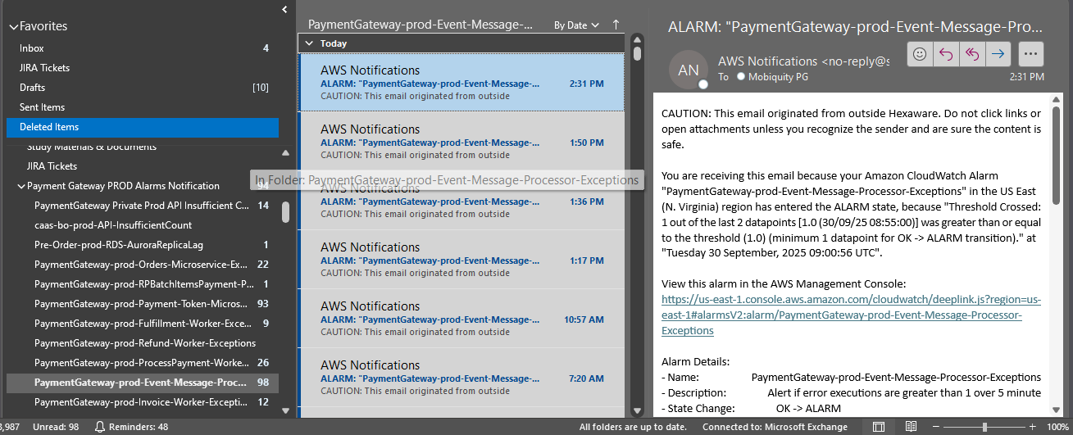

- If any Event Message Processor or AFS alarms getting triggered, then the NOC (Network Operations Center) Team should verify the “List of Alarms with Action Item” excel sheet and inform the On-Call (on weekends). These alarms are low priority but still there might be few 5xx issues that can be triggered if in case of a huge spike occurring. So, focus more on occurrences while working on these exceptions.
Sample CloudWatch Alarms:
- Amazon CloudWatch Alarm "PaymentGateway-prod-Event-Message-Processor-Exceptions" in the US East (N. Virginia) region has entered the ALARM state, because "Threshold Crossed: 1 out of the last 2 datapoints [1.0 (30/09/25 08:55:00)] was greater than or equal to the threshold (1.0) (minimum 1 datapoint for OK -> ALARM transition)." at "Tuesday 30 September, 2025 09:00:56 UTC".
- Amazon CloudWatch Alarm "PaymentGateway-AFS-prod-Transactiondata-firehose-ElasticsearchDataFreshness" in the US East (N. Virginia) region has entered the ALARM state, because "Threshold Crossed: 1 datapoint [379.0 (30/09/25 05:11:00)] was greater than the threshold (370.0)." at "Tuesday 30 September, 2025 05:16:04 UTC".
- Amazon CloudWatch Alarm "PaymentGateway-prod-API-OrdersCount" in the US East (N. Virginia) region has entered the ALARM state, because "Threshold Crossed: 1 out of the last 1 datapoints [6003.0 (29/09/25 14:28:00)] was greater than or equal to the threshold (6000.0) (minimum 1 datapoint for OK -> ALARM transition)." at "Monday 29 September, 2025 14:43:26 UTC".

PROCEDURE FOR TRACKING THE ALARM:
After we intimate to the respective persons, we should make a note of the respective alarms which are intimated in an Excel sheet stating the date and time the alarm was raised, the description of the alarm, to whom we inform and the time we pass the information.

STEPS TO MONITOR THE JIRA TICKETS:
- To monitor the ticket, we should make use of the ticketing tool called JIRA to view the tickets.
- Logged in to JIRA ticketing tool https://jira.tigo.com.hn/issues/?filter=-1 using the common credentials
Username: mob-support | Password: ^urCZ8B12bWr
- If any tickets that have been Assigned to mob support on the specific data, the NOC Team should inform the On-Call (on weekends).
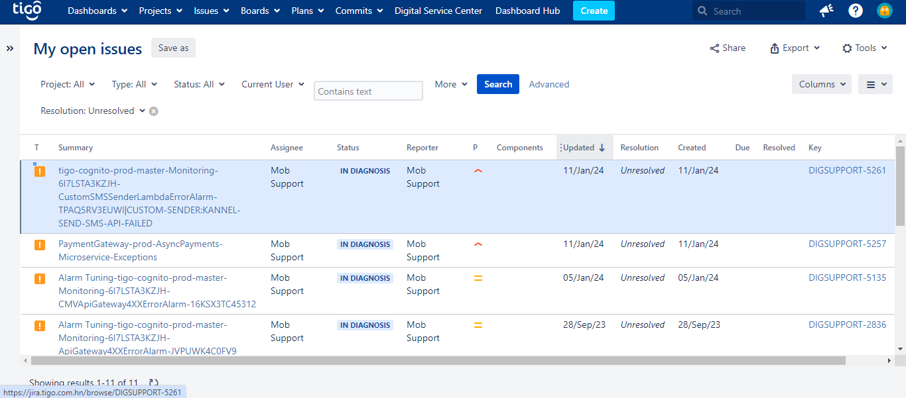
- Like alarm, we should note the tickets in the Excel sheet stating the date and time the ticket was raised, the ticket description, to whom we inform, and when we pass the information.

SEVERITY FOR ALARM AND JIRA TICKETS:

ALARM SEVERITY | JIRA TICKET SEVERITY | ACTUAL PRIORITY
Critical | Critical | P1
Warning / High | High | P2
Major | Medium | P3
Minor / Low | Low | P4

Note: Whenever any JIRA notification is received under the name 'Mobsupport' inform the L2 Team immediately via call

ESCALATION MATRIX

HEXAWARE CLOUD TEAM ESCALATION MATRIX - MILLICOM PROJECT
Sr No | Escalation Level | Name | Designation | Email Address | Phone Nos
1 | L1 | Sadhu Rajesh | Cloud Team | SadhuR@hexaware.com | 7396431513
 |  | Pradeep Damera | Cloud Team | pradeepd1@hexaware.com | 9490851151
 |  | Venesh G | Cloud Team | veneshg@hexaware.com | 8712381509
 |  | Tetali Kalyana Lakshmi | Cloud Team | TetaliK@Hexaware.com | 8106978003
 |  | Anand M R | Cloud Team | anandm4@hexaware.com | 8610976780
 |  | Dharanya S K | Cloud Team | dharanyas@hexaware.com | 8921924728
 |  | Manoj Kumar | Cloud Team | manojk25@hexaware.com | 9597226869
2 | L2 | Nihal N | Project Manager | NihalN@hexaware.com | 9894034537 / 8838966898
3 | L3 | Ravi Gunasekar | Delivery Manager | ravig5@hexaware.com | 9840188289
4 | L4 | Sundeep Trehon | Delivery Head/Director | SundeepT@hexaware.com | 9731966811

